Abstract – Currently the Generative Adversarial Networks (GANs) have their various elegant theoretical approach and impressive performance as generative models. These tools offer a lot where data availability is limited. However, a common challenge with GANs is their tendency to concentrate more on the training data points, potentially leading to overfitting and privacy concerns, especially when handling sensitive data like electronic health records.
To deal with this issue, we propose an approach called Differentially Private GAN (DPGAN). Our method introduces carefully adding noise into the gradients during the learning process, to ensuring differential privacy within GANs. We provide rigorous theoretical guarantees for privacy preservation and offer comprehensive empirical validation. This paper demonstrate that DPGAN effectively balances data quality and privacy, generating high-quality data points while maintaining a reasonable level of privacy protection.

Index Terms— Differentially Private, Generative Adversarial Network, Training data, sensitive data.

INTRODUCTION
In recent years, the data is required in every domain. And now a days data is like oil, and various domains has used the data for rapid advancement of computer hardware and software devices. Numerous data mining methodologies have emerged to analyze these vast datasets, with deep learning standing out as a prominent example. However, while deep learning often thrives on extensive training data, certain domains present challenges due to limited data availability, particularly in Medicine and Health Informatics, where it is impossible to get as much data as we want.
In health fields, each patient’s data is crucial for individual-level analysis, yet global have significantly limited patient data, because privacy concerns restrict to medical data.
For collecting, constructing high-quality data is remains a formidable task.

By considering this factor, this paper presents the concept of a Differentially Private Generative Adversarial Network (DPGAN) as a solution. DPGAN ensures robust privacy control for training data through the concept of differential privacy. This proposed methodology carefully add noise and gradient clipping techniques. Additionally, we utilize the Wasserstein distance as a more pragmatic metric for approximating the disparity between probability distributions, contrasting with the commonly used JS-divergence in GANs.

While prior research has developed into the exploration of differential privacy in deep learning models, this unique approach reduces unnecessary distortion while upholding the Lipschitz property of the loss function, thus guaranteeing a desirable level of privacy. Unlike existing privacy-preserving frameworks for deep learning, where privacy loss escalates with the quantity of labelled data in public datasets, DPGAN maintains a consistent level of privacy regardless of the volume of generated data. This adaptability makes our methodology suitable for a wide range of real-world applications. Unlike other privacy-preserving deep frameworks where privacy loss scales with the labelled data amount in public datasets, DPGAN's privacy loss remains unaffected by the volume of generated data.
The Implementation of DPGAN requires proper expertise in both ML and privacy preserving technique, and it use additional computational overhead, leading to training time and resource consumption. It should maintain balance between privacy and creating new data.

Procedure or Method

Algorithm used:
- First download the MNIST dataset (handwritten digit from 0-9).
- First initialize the parameters of discriminator and generator.
- Then add Noise by Gaussian Noise mechanism during training phase to ensure differential privacy.

- Create the discriminator and generator model.

- Take a Sample of real data points from the training data, Compute the gradient of the Wasserstein distance between the real data and the generated data distribution with respect to the discriminator parameters.

- If the fake image is distinguishable by the discriminator, then update the generator and distinguisher by using RMSProp(Root mean square propagation) optimizer for better distinguish between real and fake image.

- In last find the loss by both generator and distinguisher.

Flowchart:
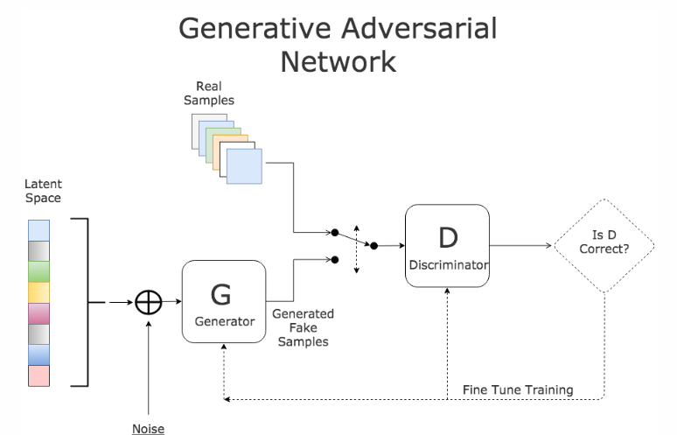

Dataset used (MNIST):
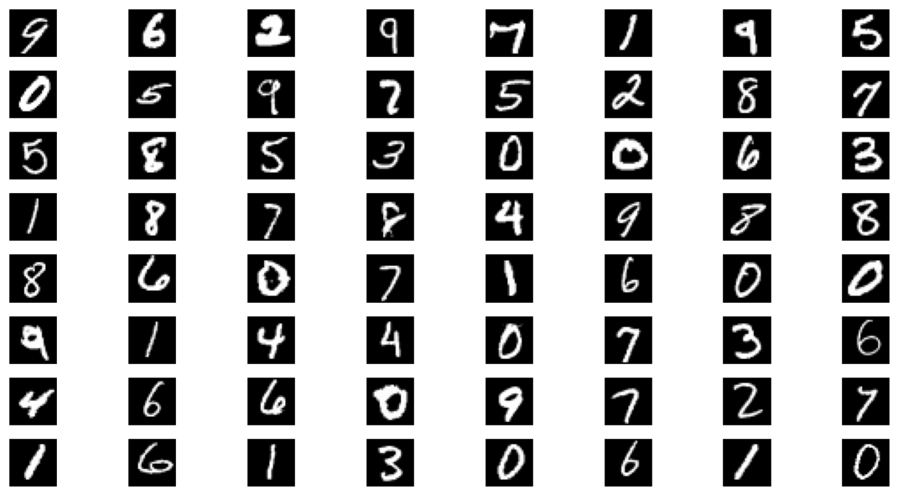

DPGAN on Electronic health records:

The actual use of Differentially Privacy is needed in case of sensitive data (MIMIC-III) like patient’s health record, so that the real application is done in health records. The medical and health are such domains where it is impossible to get as much data as we want. So, this model helps to generate more health records so that it helps to analysis and develop more equipment’s which will helpful for patients.

The Synthetic data generated by DPGANs can be used for testing and evaluating machine learning models without accessing real patient data. This allows researchers and developers to assess the performance and generalization ability of their models in a privacy-preserving manner.

DPGANs enable healthcare organizations to generate synthetic datasets that can be shared with researchers, healthcare providers, and other stakeholders without compromising patient privacy.

As we add more noise than the data generated by this model get more deviated from real training data, which ensures that the privacy is preserved.

Results
Results and Experiment:

Output (Without apply Differentially Privacy):
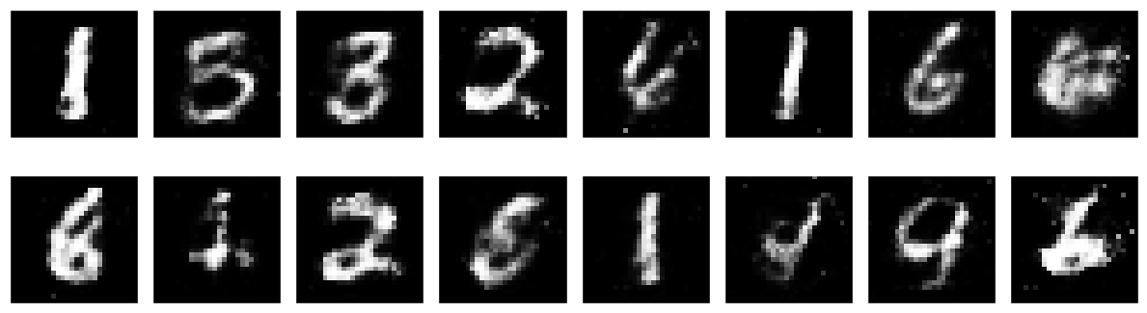

Output after apply Differentially Privacy:
With ϵ = 20.0
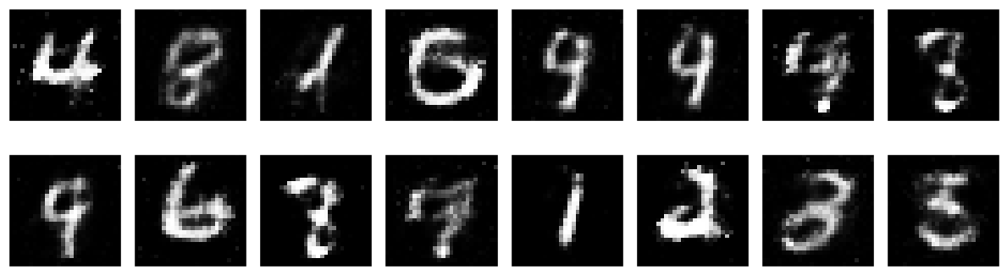

With ϵ = 11.0
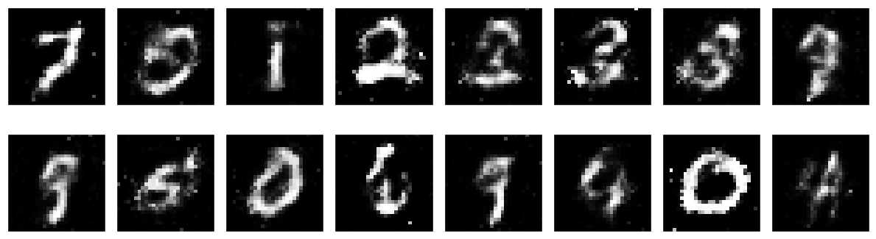

With ϵ = 7.0
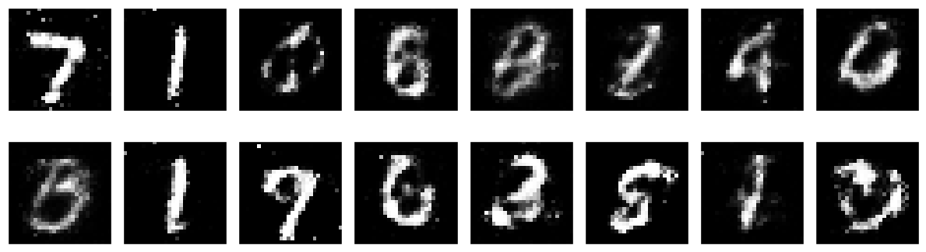

Here we can see that as more noise is added then the diagram is got more blurred, hence the privacy is preserved.

Loss vs Epoch plot:
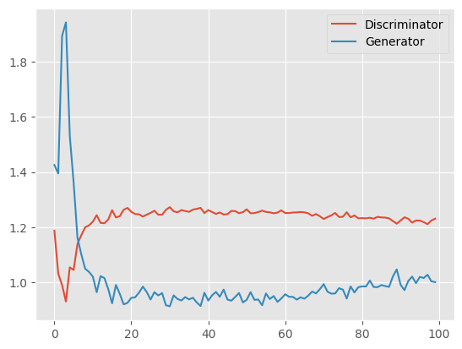

Conclusion
In this paper, it proposed a privacy preserving generative adversarial network (DPGAN) that preserves privacy of the training data. Here the privacy is preserved by add noise by Gaussian noise mechanism. Mainly privacy is required in sensitive data like hospital data, so that we can generate new health record data by considering the privacy of patients.
Acknowledgment
DPGAN requires careful implementation and it can be technically challenging, as it requires generating high quality synthetic data. And high expertise should require as it requires privacy of patients.
References

- https://arxiv.org/abs/1802.
- https://www.kaggle.com/datasets/olafkrastovski/handwritten-digits-0-9J. Williams, “Narrow-band analyzer (Thesis or Dissertation style),” Ph.D. dissertation, Dept. Elect. Eng., Harvard Univ., Cambridge, MA, 1993.
- https://physionet.org/content/mimiciii/1.4/ (Journal Online Sources style) K. Author. (year, month). Title. Journal [Type of medium]. Volume(issue), paging if given. Available: http://www.(URL)
- R. J. Vidmar. (1992, August). On the use of atmospheric plasmas as electromagnetic reflectors. IEEE Trans. Plasma Sci. [Online]. 21(3). pp. 876—880

 

